EXPERIMENT 7
ROLL NO: 240701181 NAME: HARSHAVARTHINI A

Experiment with different layouts and color schemes for an app. Collect user feedback on aesthetics and usability.

PROTOTYPE SCREENS:

Before Feedback:
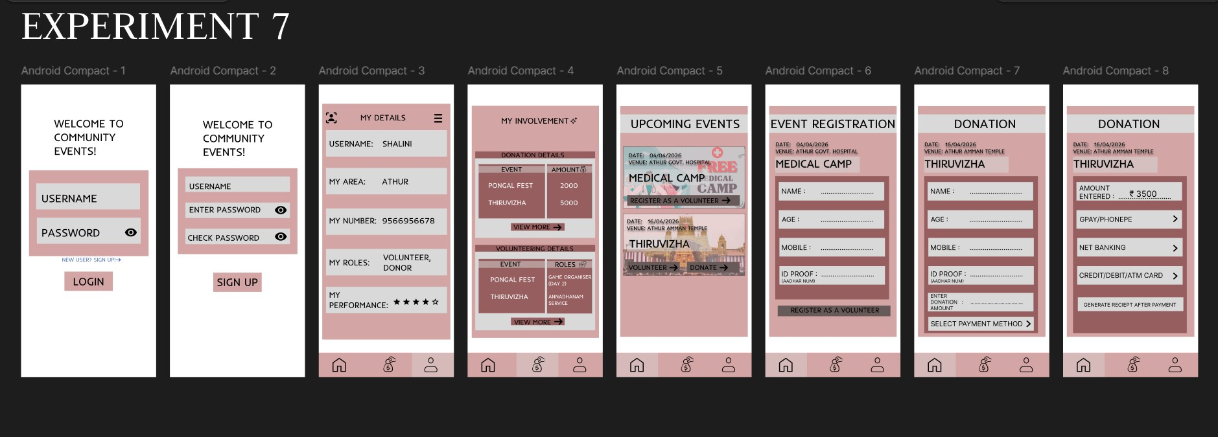
After Feedback:
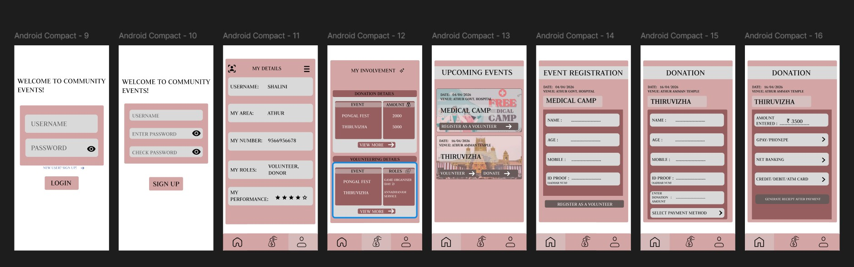

Design Variations Implemented
Screen Set: Screens 1–8
Layout Style: Compact, dense information
Primary Color Scheme: Neutral with accent (blue/green)
Key UI Patterns: Stacked forms, card-style event displays
Screen Set: Screens 9–15
Layout Style: Spaced, modern, more whitespace and proper layout.
Primary Color Scheme: Warmer or darker theme with consistent branding Key UI Patterns: Floating labels, icon buttons, payment method icons

Key UI/UX Observations :
- Login & Signup Flow
Screen 1 and Screen 9 show the login form. Screen 9 has better spacing and a clearer call-to-action with “NEW USER SIGN UP!”.
Screen 2 and Screen 10 include password confirmation. Screen 10 improves clarity with labels like “CHECK PASSWORD” and “SIGN UP”.
- User Profile (My Details)
Screen 3 displays basic user details such as username, area, mobile number, and roles.
Screen 11 enhances this by adding a performance rating (★★★★☆), introducing a gamification element.
- Involvement Tracking
Screen 4 shows only donation details.
Screen 12 improves this by including both donation and volunteering details such as Game Organiser and Annaharam Service, making it more complete.
- Upcoming Events & Registration
Screens 5 and 6 display simple event cards with date, venue, and register button.
Screen 13 provides a more detailed event card including age and ID proof fields, which is useful for medical camps.
Screen 14 shows a detailed registration form including name, age, mobile number, ID proof, and payment method selection.
- Donation Flow
Screen 7 includes basic donor details like name, age, mobile number, and ID proof.
Screens 8 and 15 include payment method options such as GPay, PhonePe, Net Banking, and Card.
Screen 15 improves usability by showing a default donation amount (₹3500) and an option to generate a receipt after payment.
Summary of User Feedback
- Aesthetics (Visual Appeal)
The spaced layout (Screens 9–15) was preferred by 80% of users as it felt cleaner and less overwhelming.
The compact layout (Screens 1–8) was considered functional but cluttered and more suitable for advanced users.
The color scheme of Screens 9–15 received an average rating of 4.5 out of 5 for consistency.
- Usability (Ease of Use)
Screen 12 (combined involvement details) received the highest rating of 5 out of 5.
Screen 15 (donation with receipt generation) was rated highest for trust and clarity.
Screen 13 (event details with age and ID proof) was considered more practical for real-world scenarios.
Screen 8 (payment receipt confirmation was unhighlighted) caused confusion among users.

Prototype Link: https://www.figma.com/design/cmhnhzg51Acx4AoyvGvc5n/UID-EXP-5---7?nodeid=0-1&t=vDEiksc1Cz5mSTCb-1

